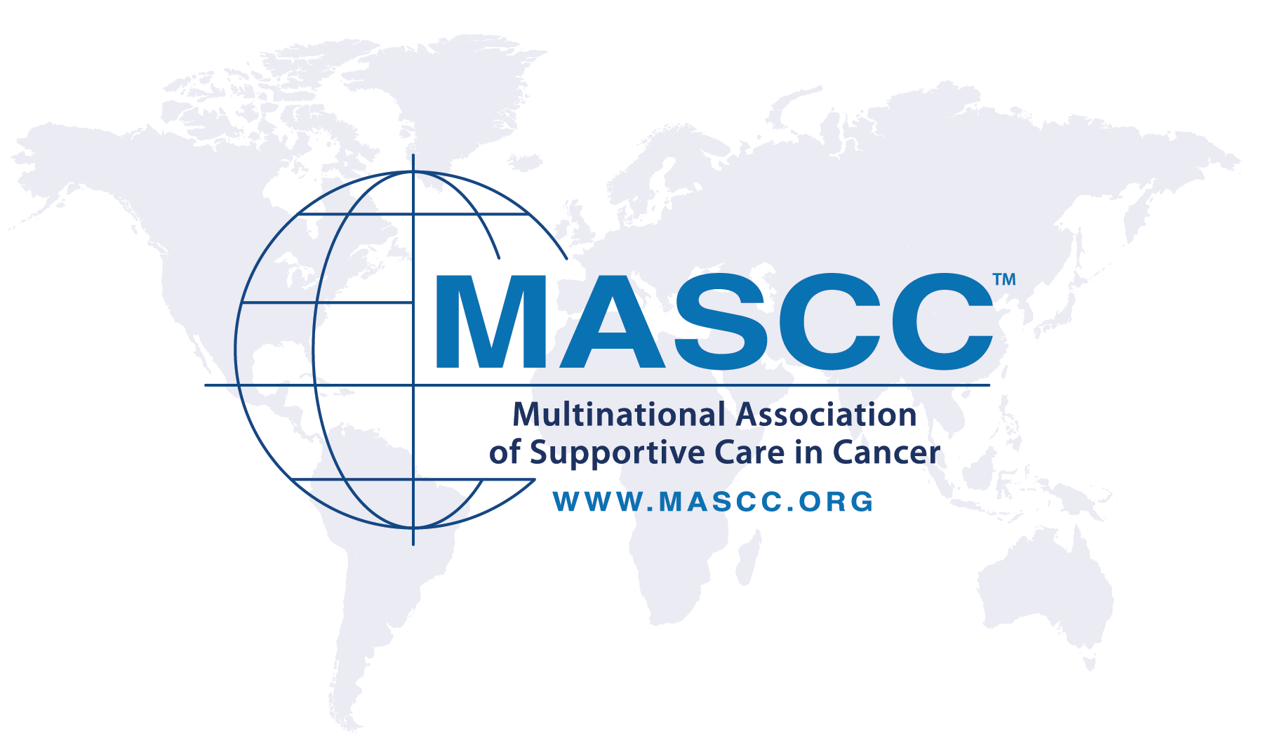

Designated Centers of Excellence
in Supportive Care in Cancer

Certification Program

Supportive Care Makes Excellent Cancer Care Possible
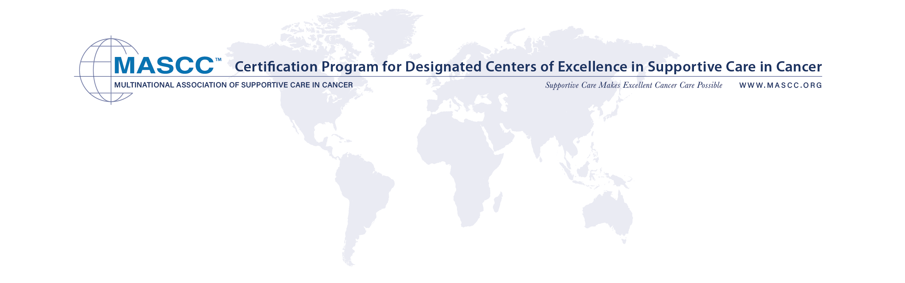
To Be Completed by Applicant

General
First Name/Surname of Applicant:
Title: | Specialized in:
E-mail:
Phone: |  | Fax:

Are you directly involved in cancer supportive care? If yes, please specify.

Institute:
Mailing address:
Department:
Unit:
Head of the Unit: | Head of the Department:
E-mail: | E-mail:
Phone: | Phone:

Head of the Institute:
E-mail:
Phone:

Membership
Are you a MASCC member? If yes, please specify your member ID, found on your member login page.
Member ID #:

Guidelines
What guidelines do you follow in your daily oncology clinical practice? (Please check all that apply.)
MASCC guidelines
ASCO guidelines
ESMO guidelines
Other(s) – Please specify:

Center Details

To what type of institute does this application relate? (Please check all that apply.)
General Hospital
University Hospital
Comprehensive Cancer Center
Private Clinic
Tertiary Center
Primary Care
Community
Other – Please specify:

Types of cancer treated at your center (Please check all that apply.)
Only patients with solid tumors
Only patients with hematological malignancies
Both
Limited types – Please list:

Patient age groups (Check all that apply.)
Pediatric
Adolescent and young adult
Adult
Geriatric
Services available at your center (Please check all that apply.)
Medical Oncology
Inpatients | Yes | No
Day care | Yes | No
Outpatients | Yes | No

Radiation Oncology
Inpatients | Yes | No
Day care | Yes | No
Outpatients | Yes | No

Hematology
Inpatients | Yes | No
Day care | Yes | No
Outpatients | Yes | No

Supportive Care
Inpatients | Yes | No
Day care | Yes | No
Outpatients | Yes | No

Palliative Care
Hospice | Yes | No
Day care | Yes | No
Outpatients | Yes | No

Does the center provide emergency care for treatment-related toxicities?
Yes
No

Clinical Activities
(Eligibility Criteria Checklist – 1/3)

In addition to checking all applicable responses below, please attach additional explanations
relating to items 1 through 7.

1. Supportive care features at your center (Please check all that apply.)
Which of the following supportive care therapies are provided to patients receiving cancer treatment at your center, and in what settings are they provided? Please attach detailed information about the settings for each supportive care therapy — for example, a European dedicated supportive care unit? A Wisconsin-based dedicated acute care unit?
Blood product transfusions (blood, platelets, plasma)
Infusion of immunoglobulins, human albumin, human plasmatic protein, antibiotics, antifungals and
antivirals, iron, electrolytes, analgesics, diuretics, steroids, octreotide, H2-antagonist, glutathione,
antiemetics, or antihistamines
Infusion of bisphosphonates/denosumab
Hydration following high-dose chemotherapy
Hydration for acute and chronic renal failure
Intravenous hydration, possibly in association with electrolyte supply, and/or multivitamin, protein,
lipid supply, in patients with compromised ability to eat and drink properly, or with toxicity due to
radiotherapy or chemotherapy (i.e., diarrhea, nausea, vomiting, and oropharyngeal high-grade
mucositis)

How are outpatients with treatment-related toxicities managed?
Unplanned visits: No Yes
Who takes care of them?

Unplanned hospitalization: No Yes
Who takes care of them?

Followed as outpatients in a day-care service: No Yes
Who takes care of them?

2. General features at your center (Please check all that apply.)
Who provides toxicity management and pharmacological support?
Treating oncologists
Treating radiotherapists
Dedicated supportive care staff (including allied health) inside the oncology unit
Dedicated supportive care staff (including allied health) inside the radiotherapy unit
Dedicated supportive care staff outside the oncology/radiotherapy unit
Emergency department
Referred elsewhere – Please specify:

Who manages late toxicities during survivorship?
Treating oncologists
Treating radiotherapists
Dedicated supportive care staff
Referred elsewhere – Please specify:

Who provides psychological and social support?
Specialist clinical psychologists
Social workers
None
Other – Please specify:

Who provides spiritual support?
Chaplain
No one
Other – Please specify:

3. Dedicated multidisciplinary or multi-professional teams (MDTs) (Please check all that apply.)
Does your center have dedicated MDTs to provide supportive care to cancer patients?
No
Yes – Please describe your MDTs for supportive care.
What types of expertise are provided by your MDTs? Please describe.

4. Logistics (Please check all that apply.)
In what settings is supportive care provided?
In dedicated structures
Outside dedicated structures
Please describe.

How many hours per day is care provided?
Less than 6 hours/day
More than 6 hours, but less than or equal to, 12 hours/day
24 hours/day
Other – Please specify:

How many days per week is care provided?
5 out of 7 days
7 out of 7 days
Other – Please specify:

Does this include or exclude holidays?
Includes
Excludes

Is care available for unplanned patient visits (as outpatients or day service)?
Available
Not available

Does the service provide dedicated contacts with patients?
No dedicated contacts
Dedicated phone number – Please specify the activity time:
Dedicated mobile number – Please specify the activity time:
Dedicated fax line
Dedicated e-mail or other electronic devices, such as apps, social networks, etc.

5. Staff (Please check all that apply.)
Please specify the type and number of people who provide supportive care.
No one
Doctors – number:
Nurses – number:
Administrators – number:
Volunteers – number:
Social workers – number:

6. Clinical practice (Please check all that apply.)
Does the service provide toxicities management for patients receiving cancer treatment other than immunotherapies?
No, referred to others
Grade 1-2
Grade 3-4
Only outpatients
Outpatients and inpatients (when needed)

Does the service provide toxicities management for patients receiving immunotherapies?
No, referred to others
Grade 1-2
Grade 3-4
Only outpatients
Outpatients and inpatients (when needed)

Does the service manage cancer-related symptoms during cancer treatment?
No, referred to others
Yes
Only outpatients
Outpatients and inpatients (when needed)

Does your center manage common comorbidities in cancer patients?
No, referred to others
Yes
Only outpatients

Does the service routinely use validated symptom assessment tools (outside of clinical trials)?
No
Yes – Please list:

Does the service routinely use validated quality-of-life (QoL) assessment tools?
No
Yes – Please list:

Does the service include activity monitoring through electronic records?
No
Yes

Does the service provide psychological specialist support?
No
Yes

Does the service provide rehabilitation services?
No
Physiatric
Phoniatric
Swallowing experts
Lymphedema experts
Other – Please specify:

Does the service provide other non-pharmacological support?
No
Yes – Please list:

7. Palliative care features at your center
Please describe the types and level of integration between supportive care and palliative care staff.

How is end-of-life care and symptom management provided?
Integrated outpatient paths
Hospice

Does your palliative care outpatient service accept referrals of patients with prognoses substantially greater than three months?
No
Yes

How are palliative care experts involved in patient care?
Directly within the MDT
Called on if needed
The patient or oncologist can request palliative care services.

Are medical oncology trainees provided with clinical experience on a palliative care service?
No
Yes

Research and Educational Features of Supportive Care Service
(Eligibility Criteria Checklist – 2/3)

Research
What types of research are center staff involved in?
Oncology (general, specific)
Supportive care in cancer patients
Palliative care in cancer patients

Research types
Basic
Translational
Clinical
Other – Please specify:

Publications in peer-reviewed journals
List the 3 papers with highest impact published in the past 2 years (oncology, general).
1.
2.
3.
Total number of oncology publications in the past 2 years:
List the 3 papers with highest impact published in the last 2 years (supportive care).
1.
2.
3.
Total Number of supportive care publications in in the past 2 years:

What are the professions of the center’s researchers? (Check all that apply.)
Doctors
Nurses
Allied health

Educational
In what disciplines do center staff teach students? (Check all that apply.)
No teaching activities
Medicine
Nursing
Allied health

What levels and numbers of students receive training at the center?
Undergraduate – number:
Postgraduate – number:
Postdoctoral – number:

If you have oncology trainees, do annual lectures include supportive care topics?
No
Yes

How many center staff have given conference presentations in the past 2 years?
Oncology/Hematology – Number at national conferences:
Oncology/Hematology – Number at international conferences:
Supportive Care – Number at national conferences:
Supportive Care – Number at international conferences

Adherence to International Guidelines
(Eligibility Criteria Checklist – 3/3)

Please answer the following questions, indicating the reference guidelines or similar.
Please indicate the reference guidelines for the following topics.
CINV | References No References  Principle guideline:  Others:
Thromboembolic prophylaxis | References No References  Principle guideline:  Others:
Bone metastases | References No References  Principle guideline:  Others:
Febrile Neutropenia | References No References  Principle guideline:  Others:
Pain | References No References  Principle guideline:  Others:
Oral mucositis | References No References  Principle guideline:  Others:
Immuno-related toxicities | References No References  Principle guideline:  Others:
Fatigue | References No References  Principle guideline:  Others:

Thank you for your participation.

For eligibility, the application must be signed by the following people.

Applicant | Insert digital signature below
Name:
Director of the Unit | Insert digital signature below
Name:
Director of the Department | Insert digital signature below
Name:
Director of the Institute | Insert digital signature below
Name:

Date:

Please email this completed application to the MASCC office.
Ruxandra Nedu, MASCC Associate Director
rnedu@mascc.org

