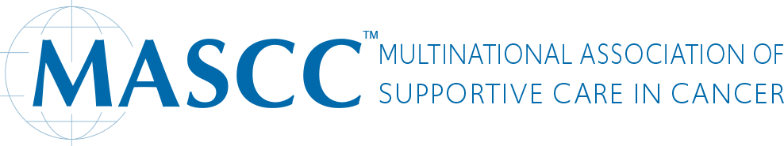

MASCC Board of Directors Elections 2022-2024

Potential Candidate Form

Please send this completed form and a photograph of the potential candidate to
Ruxandra Nedu at rnedu@mascc.org no later than February 8, 2022

SECTION A-MASCC Member to be considered (potential candidate/nominee to complete this section):

Name:

Country:

Telephone:

E-mail:

Profession & credentials:

Current Position:

Current Place of Employment:

(Note: phone and e-mail will not appear on the ballot)

What contributions have you made to MASCC/ISOO to date? (List in bullet form < 250 words)

If you served in a leadership position in MASCC/ISOO currently/previously (e.g., Board, SG Chair/Vice Chair, Committee Chair etc), describe in detail the accomplishments from your contributions, for example, new initiatives, committees, projects led, guidelines, publications etc (list in bullet form <250 words)

What leadership positions have you held in other organizations? (Maximum of five)

1.
2.
3.
4.
5.

What is your strategic vision for MASCC? (< 150 words)

Why do you think you will be an effective Board member (<150 words):

A recent photograph that will be included to the ballot needs to be included when submitting this form to rnedu@mascc.org

SECTION B – Endorsement of Nomination by two(2) current MASCC Members

First Endorsement of Potential Candidate/ Nomination:

Name:

Profession:

E-mail:

Phone:

Second Endorsement of Potential Candidate/Nomination:

Name:

Profession:

E-mail:

Phone:

