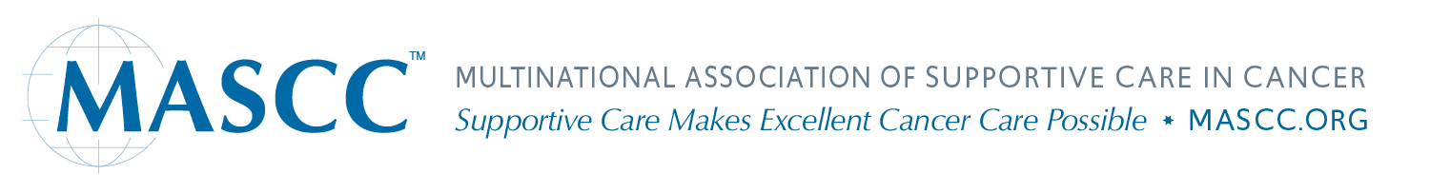

MASCC Development Fund

Contribute to the growth and expansion of MASCC's programs and outreach. MASCC is a tax-exempt 501(c)3 corporation. Give a tax-free donation to a designated MASCC fund that will be used to support important MASCC programs. Study group projects, web site initiatives, Travel Scholarships, Young Investigator Awards, and scholarship memberships are examples of how the fund will be used. We appreciate any and all levels of giving.

To make a donation, please fill in the information below.
Donations are also accepted through Paypal on the mascc.org website or when you renew your membership.

Name:
Address:
Email:
Donation amount in US dollars: $
Enclosed is my check – made payable to MASCC
Charge to my credit card
Number:
Expiration date: Card Security Code (CSC/CVV)#:

Return to:

Melissa Chin, MASCC Executive Director
Multinational Association of Supportive Care in Cancer
412- 16 Industrial Parkway South, Aurora, ON, L4G 0R1, Canada
Email: mascc.office@mascc.org

MASCC US Tax ID Number: 72-1510213

Donations are also accepted online at www.mascc.org through Paypal.

