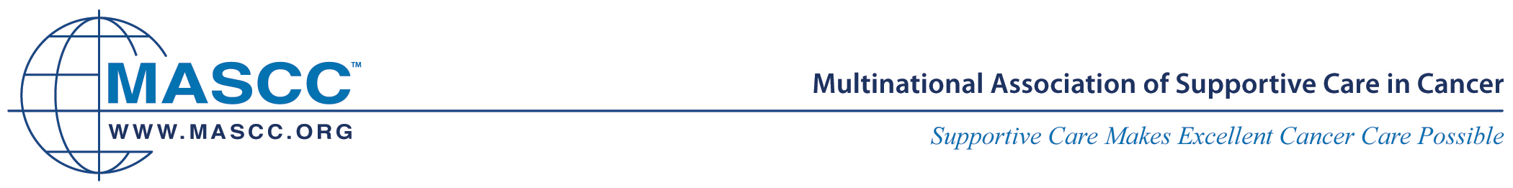

Process for Translating from English to Other Languages

Forward Translation
The forward translation method requires having a bilingual expert translate the English version of the document or tool to another language.

For MASCC guidelines, one of two approaches can be used.
- For cases in which MASCC has a sponsor, the best translation provider is Mapi translation services. They are expensive, reliable, do quality work, are need-oriented, and have a good reputation.
- For cases in which no sponsor is available, a bilingual MASCC member may be asked to do a careful translation. A second bilingual health care professional is then identified to review the translation, with the original English version at hand. The two translators resolve any differences.
As an example, the forward translation method is used for medical textbooks and treatment guidelines that are translated into multiple languages. Medical textbooks and guidelines are intended for health care professionals. The method is rapid and cost-effective. Translators may be rewarded with one year of free MASCC membership, at the discretion of MASCC Executive Director.

Forward/Back Translation
The forward/back translation method requires, at a minimum, having one bilingual expert translate the English version of the document or tool to another language (forward translation) and having a second bilingual expert independently translate the tool that is in another language back into English (back translation) without any reference to the original English wording. The original tool and back-translated version are then compared and if discrepancies are noted, the problematic terms or passages are retranslated and blindly back-translated by another bilingual expert until no error of meaning is found.
As one example, the forward/back translation method is suitable for materials such as quality-of-life instruments that require patient input. The method is time-consuming and expensive.

Approved, ExCom 31/8/2010

